**INTRODUCING COVID-19 CONTACT TRACKING APPLICATION**

**CordonOff** – “First Line of Defense Against COVID-19”

**CordonOff** – “A cost-effective alternative to blanket lockdowns”

**Intro (Optional)**:

Covid-19 has killed more than 200,000 people and triggered a severe global economic recession. Governments want to get people back to work, and a key part of this is contact-tracing technology that helps authorities track the virus and warn citizens who may be infected to stay home or get tested.

As governments deal with this intensifying crisis and plan for post-peak management of the pandemic, many are looking to digital surveillance networks to reduce the spread of the disease.

Awareness of the seriousness of this threat and a determination to take all reasonable precautions in this new reality is driving interest in available tools for tracking and monitoring capabilities in spaces where people gather. Recent events have shown us the value of early detection and tracking data that allows for quick identification of the possibly infected.

To get ready for the new reality, we need to start acting now, leveraging the proven technology that is already widely adopted on the market. Digital surveillance enables real-time contact tracing to quickly identify and manage outbreaks at the local level, predict medical resource needs to pre-emptively allocate them accordingly, and measure adherence to national emergency directives and policies.

**What is CordonOff?**

**CordonOff** is a **Digital Contact Tracing and Surveillance Application** designed to slow down the spread of the coronavirus. By using this application enforcement agencies and public-health workers can track and monitor infected individual's travel history and determine who they may have come in contact with while they were contagious. These contacts are notified and supported through a period of quarantine—until they develop symptoms, pass the window of risk, or are proven not to have been exposed.

It provides a more scalable approach to traditional contact tracing, which relies on patients’ memories of recent exposure to others. As the coronavirus spreads rapidly across the globe, traditional contact tracing efforts are unlikely to keep up and would require an “army” of public health workers.

Digital surveillance is most effective when it is supported by widespread testing and advanced isolation and quarantine approaches, but it can have a significant impact on its own in limiting the spread of the disease through identifying and notifying contacts, providing follow-up monitoring and support, and even alerting contacts when the status has changed.

**Why CordonOff?**

CordonOff Application allows enforcement agencies to model the spread of the Coronavirus on the basis of AI models based on multiple variables as defined by the WHO. The App was created with five goals in mind:

* Control the virus spread by identifying likely infection chains early on.
* Create a higher level of people safety health awareness.
* Reduce the external costs of false testing.
* Improve containment plans by tracing back individual movement using geo-fencing.
* Notify to get quarantined/tested (if got close contact with an infected person)

**How CordonOff Works?**

Contact Tracer or Public Health worker installs and registers the infected individual’s details in the application which generates a unique NFC tag encoded with details like case ID number, name, age, contact information, quarantine location, and days since exposure.

Once installed on the individual's smartphone, the app assigns a unique device ID -- a random number and maps with the NFC Tag IDs generated and assigned to the individual. Records of the individual’s movement history and encounters are stored in the device for up to 14 days before going to a central server run by the government entity using the system. What’s more, the app connects to devices even when they don’t have an internet connection.

The second part of the system is a web portal that aggregates the unique IDs from smartphones. Health workers can also upload results from people tested for COVID-19 and can adjust health statuses when there is a change.

When adding someone to the system, contact tracers ask people with confirmed positive COVID-19 tests about their occupation in case they need to follow up on workplace exposure, living situations to alert roommates or neighbors, and health provider information should they need to be referred for care. They can also click on people assigned to them to get additional information such as recent notes about the case and details on whether they’re symptomatic.

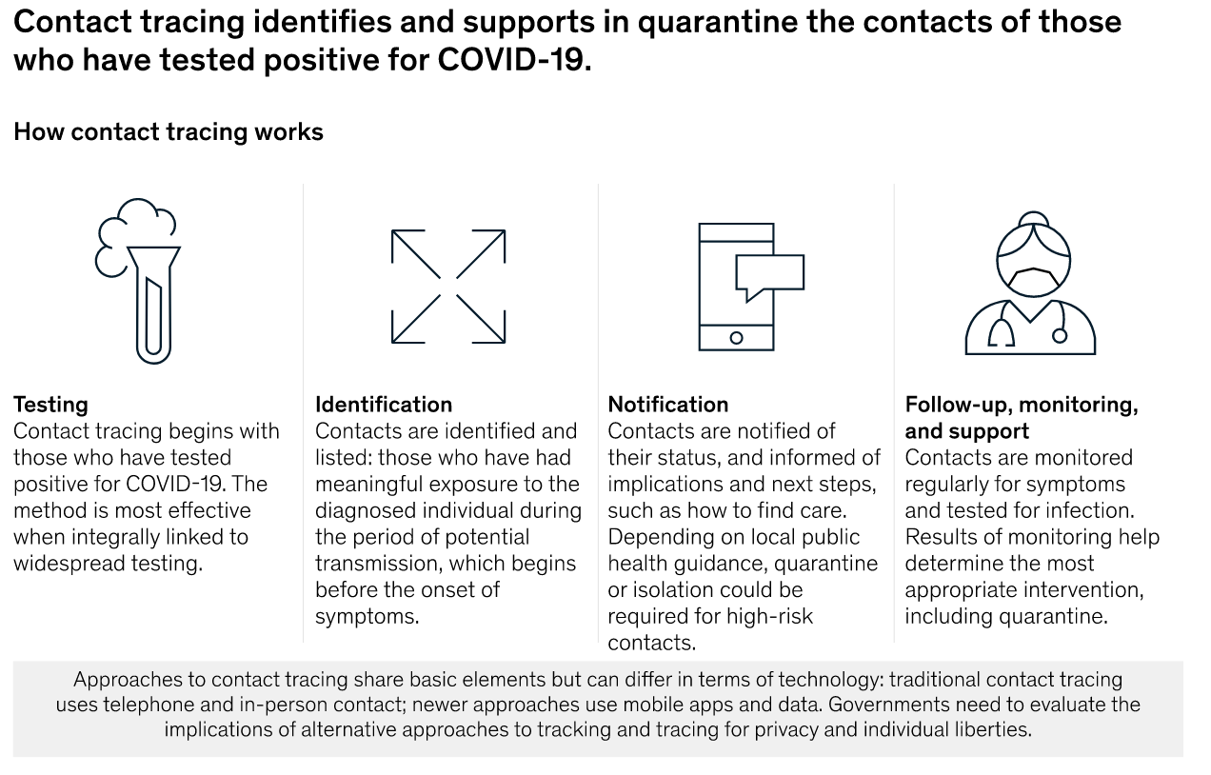

**Features of CordonOff - Contact Tracing:**

**CordonOff** is an important tool to reduce the spread of infectious diseases like COVID-19. **CordonOff** is primarily built with a privacy-preserving protocol for community-driven contact tracing using NFC/Bluetooth devices, that allows for global interoperability.

Once enrolled and deployed, this system would use the individual’s smartphone location to identify any geo-fencing violations and proximity data of the NFC tag to detect possible exposure events while ensuring that privacy is preserved and data is secure.

With it, organizations can confidently assess operational risks and wellness while continuously and proactively monitoring for potential liability impacts using real-time decision and analytical risk information. The web platform and app feature:

**Management Communication Hub**: Manage users, view case status (active, pending, quarantined, recovered), and access contact tracing.

**Risk Analysis Dashboard**: Gives agencies/health workers an overall risk score based on anonymized data.

**Proximity Alerts**: Notifies individuals if they are too close, as defined by MoH guidelines.

**Contact Tracing**: Automatically alerts individuals of contact with a confirmed case and instruct the next steps.

**Symptom Log:** Allows agencies/health workers to track daily symptoms to manage personal risk and offers a personal risk score.

**Access Manager**: A daily QR Code notifies individuals if they meet the accepted risk profile. It Can be used to allow or prevent access to physical locations.

**Cybersecurity and Privacy**: Radiofrequency, Bluetooth, NFC proximity identifiers (NFC), security encryption and digital tokens are leveraged to ensure data privacy and security at the highest levels.

**Advantages of CordonOff - Contact Tracing**

In the context of contact tracing to curb the spread of Covid-19, CordonOff solution can increase productivity, limit exposure of the workforce, and lower costs. It can also increase the speed of response, which modeling shows to be critical to the overall success of contact tracing.

CordonOff system is designed for decentralized proximity logging and supplements centralized contact tracing by public health authorities. Proximity logging using NFC/Bluetooth addresses a key limitation of manual contact tracing: that it is dependent on a person’s memory and is therefore limited to contacts that a person is acquainted with and remembers having met. CordonOff, therefore, enables contact tracing to be more scalable and less resource-intensive.

The proposed method of digital contact tracing offers several key advantages over traditional contact tracing and alternative forms of digital surveillance being used globally.

**Identification:** Those afflicted with COVID-19 and their supporters can use CordonOff to identify contacts, entering names into lists, or using digital data to create such lists. On the higher end of the technology spectrum, some countries are using digital data in applications that help automatically identify contacts by GPS or Bluetooth technology.

**Notification:** CordonOff can also be used to notify contacts and generate anonymized mapping to notify the public of high-risk areas. (This helps reach those without access to mobile apps.) CordonOff solution comprises both a smartphone application (CordonOff Me) and a web application (CordonOff Web).

**Monitoring and support**. CordonOff solution can also be used for monitoring any changes in the symptoms of contacts and support daily digital check-ins or compliance monitoring.

**BENEFITS OF USING CORDONOFF NFC BASED CONTACT TRACKING:**

CordonOff solution enabled with NFC based contact tracking helps to flatten the curve and offer the following benefits to government and health agencies:

**Contact Information**: By tapping their smartphones to the contact’s NFC tag, health workers can learn about their symptoms, and location history in real time.

**Patient Education**: tags can also link to websites or apps that separate fact from fiction and direct the patients to relevant health agencies.

**Self-Assistance**: Digitised, step-by-step instructions can be delivered to patients to help ensure self-assistance on symptoms and other diagnostic tools are used correctly.

**Secure Access to Test Results**: Secure registration links can be provided to patients so they can gain direct access to their test results by scanning against their allocated tag

**Contact Authentication**: NFC tags with built-in security features, such as originality signatures or AES encryption with secret keys, can help ensure authenticity and protect patient’s privacy.

**Detect and Deter Tampering**: A conductive tamper loop in the tag of an on-pack label or inside a closure can irreversibly store an opening detection and communicate the event to an NFC-enabled smartphone, removing doubts about whether one has tampered the tag.

**Track and Trace**: Health workers and government agencies can use opt-in track and trace features to address the ongoing risk of disease spread while enabling faster insights on contact movements and quicker corrective measures.

**Provide Insights to Government and Health Organisations**: NFC’s ability to collect real-time data and track analytics can be used to show where quarantine violations are taking place, while ensuring a high level of privacy and security for any personal data.

**How does CordonOff adhere to privacy guidelines?**

Consent can be an integral part of the contact tracing process for identification and enrolment. CordonOff is developed with strictly adhering to government data-sharing guidelines, minimizing data collection, and anonymizing and encrypting data to support privacy rights.

Data transferred between NFC tags and application are encrypted using strong AES key end-to-end encryption that doesn’t allow any 3rd party applications or websites to trace or reconstruct the data.

1. Third-parties cannot use CordonOff communications to track users over time

* A device’s temporary identifier rotates frequently, preventing malicious actors from tracking individual users over time by sniffing for CordonOff notifications.

1. Limited collection of personally-identifiable information

* The only personally-identifiable information collected is a phone number, which is securely stored by the health authority.

1. Local storage of location and encounter history

* Each user’s movement and encounter history are stored exclusively on their own device. The health authority only has access to this history when an infected person chooses to share it.

1. Revocable consent

* Users have control of their personal data. When they withdraw consent, all personally-identifiable data stored at the health authority is deleted. All encounter history will thus cease to be linked to the user.

